Gallagher - Ferrycarrig 5 Five Mile Road Race, 22 January 2023, 12.00 Noon

To All Competitors,

Thank you for registering your entry for the Gallagher Ferrycarrig 5 Five Mile Road Race.

The race start will be at 12.00 Noon sharp on Sunday 22 01 2023.

Number Pick up is available at the following times at the race venue, Ferrycarrig Park, home of Wexford FC (Eircode Y35 E296):

- Saturday 21 January 2023 2.00pm to 4.00pm
- Sunday 2 January 2023 10.00am to 11.45am

You are requested to attend as early as possible on Sunday. If you are local, why not get it done on Saturday. At number pick up you will collect your number (with integrated chip) and race memento. Unfortunately, we are not in a position to post out numbers this year.

Keeping the Race Green:

Our race is still plastic bottle free. Drinking water and cups will be provided on site by the Refill Ireland. Thanks to Wexford County Council for their support for this initiative.
Please also consider car-pooling, bring a reusable cup and eat up afterwards to help fight food waste!

After the race, Tea, Coffee, Cold Drinks, Sandwiches and other refreshments will be available upstairs in the Pavilion.

The race venue is Ferrycarrig Park, home of Wexford FC.
Directions to Ferrycarrig Park (Eircode Y35 E296) are as follows:

N11 Southbound (From Enniscorthy):
Approx 2 1/2 miles after Oilgate you come to Kyle Cross. Turn Right here onto the L3006 signposted Killurin. After approximately 300m turn left. Continue along this local road for approximately 1 1/2 miles. You will find the complex on your left. Marshalls will direct you to a parking space.
N11 Northbound (From Rosslare/ Wexford):
Approx 1/3 of a mile after Ferrycarrig Bridge turn left onto the L3007 signposted Newcastle. Follow this road for approx. 1 1/4 miles (including one right 90 degree bend) until you come to a right hand turn. Turn right and after approximately 1/2 mile you will find the complex on your right. Marshalls will direct you to a parking space.

From Castlebridge:

Approx one mile after Crossabeg Village you cross the N11 at Kyle Cross onto the L3006 signposted Killurin. After approximately 300m turn left. Continue along this local road for approximately 1 1/2 miles. You will find the complex on your left. Marshalls will direct you to a parking space.

From Killurin:

You will be travelling on the L3006. Before you get to the N11 there is a crossroads with an old Church on the left hand side. Turn right here. Continue along this local road for approximately 1 1/2 miles. You will find the complex on your left. Marshalls will direct you to a parking space.

The route will be signposted on the day. Parking is available on site. Please drive carefully on the approach roads to the Complex. A one-way system will be in operation for on-site traffic on the day – Please abide by the Marshall’s Directions.

Prize giving

Prize giving will be held after the race upstairs in the pavilion building.

Prizes as Follows:

 | Female | Male
Winner | €250.00 | €250.00 | Cash
Winner's Time Bonus | €100.00 | €100.00 | Cash
Second | €125.00 | €125.00 | Cash
Third | €75.00 | €75.00 | Cash
Fourth | €50.00 | €50.00 | Cash
Fifth | €50.00 | €50.00 | Cash
Vet O/40 | €50.00 | €50.00 | Cash
Vet O/50 | €50.00 | €50.00 | Cash
Vet O/60 | €50.00 | €50.00 | Cash
Vet O/70 | €50.00 | €50.00 | Cash
Teams (3) | €150.00 | €150.00 | Cash
Junior | €50.00 | €50.00 | Cash
Total Male/ Female | €1,050.00 | €1,050.00
Total Prize Fund |  | €2,100.00
The Seamus Kehoe Memorial Shield will be awarded to first Wexford Male and Female Athlete

Corporate Challenge Trophy will also be awarded.

The Course

The route is an Anti-Clockwise course.
The race starts within the curtilage of Wexford FC Complex, Ferrycarrig Park. After approximately 1/4 of a mile the participants will turn left out onto the local road through Newcastle until it reaches the L3007 at Newcastle. At this point there is a left turn at a T junction (race distance approximately 2/3 of a mile). The race then follows the L3007 until it meets the N11 at Kitestown Cross. At this point the race distance is at the 1 ½ mile mark. There is a sharp left-hand bend midway on this stretch.
At Kitestown Cross the Runners turn left and continue in the hard shoulder of the N11 for almost 1 ¾ miles until they turn left again at Kyle cross (approximately 3 ¼ mile mark).
There is a short stretch on the L3006 until turning left again at the old Community Centre onto the local road through Bromley, Kereight and back to Newcastle. There is one more left handed turn back into the Complex for the long finishing straight to the Finish which is adjacent to the Start Line.
Here is a link to the Course Map which also shows the venue location:

http://www.mapmyrun.com/routes/view/155364761
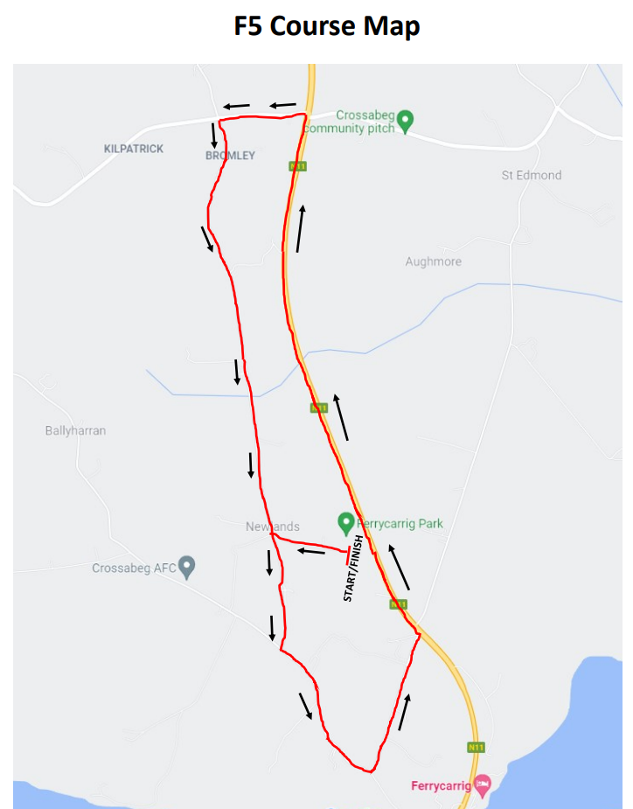

Race Rules
  - The race is run in accordance with Athletics Association of Ireland rules
  - Runners and Walkers indemnify the AAI, St Killian’s AC, Crossabeg/ Ballymurn Community Centre, Wexford FC, race sponsors and organizers or the race itself against any or all actions of whatsoever nature, whatever the same maybe arising out of their participation in the race.
  - Race Numbers must be worn on the front of the runners or walkers vest/ tee shirt or top. The race number must be clearly visible to the finishing line officials and all race marshals.
  - Proof of age for prize winners may be requested, where appropriate. Masters categories are calculated using your age on race day.
  - Any walkers or runners pushing children’s push chairs, prams or buggies must start towards the rear of the field for safety reasons.
  - No roller blades, cyclist or mechanically operated device allowed in the race
  - No dogs (or other animals) are allowed whether on lead or not.
  - Teams for the mens and ladies team event to be of any number of runners with the first three of any category to score.
  - In the Corporate Competition teams to be of any number of runners with the first two men and first two ladies of any category to score.
  - It is the participants responsibility to ensure that the organiser is aware of team membership. If you haven't entered teams in the online procedure please inform us prior to the race.
  - All marshals, stewards, Garda or other official instructions must be obeyed. Failure to obey such instructions may lead to disqualification.
  - Prizes restricted to one per entrant, except only when one is a team prize. Where a participant in the veteran categories wins a general classification prize they get the general prize only.
  - Team positions will be calculated on position not time.
  - The use of personal stereo devices is discouraged on safety grounds. Remember that race officials may make important announcements or instructions during, before or after the race which benefit your safety. Although supervised, remember the roads will not be closed and you should be aware of all potential hazards.
  - Team membership must be advised to the officials on registration.
  - The decision of the committee is final on all matters.
  - Juniors must be aged 15 to 19 years of age on the day of the race.

A special Thank you to our Sponsors:
Gallagher Insurances, Hertz, McCauley Plastering, Fehilys Chemists, Wexford Orthodontist, DHD Construction Limited, PWC, Ferrybank Motors, Hugh Boggan Motors, Neville Plant Hire, UPMC Whitfield, Wexford Auto Factors, Doyle Foley Accountants, Anthony O’Gorman Engineering, Graphedia, DNG McCormack Quinn, Coffee Express, Wexford Bus, Doyles Courtown, Rapid Locksmiths, Ken Foley, Franks Place/Greenacres and Bennett Tarmacadam.

Finally, we wish you an enjoyable day out in Wexford and good luck in the race.
Ragards

Gallagher - Ferrycarrig 5 Road Race Team

