Charlie Curran Memorial Run 2019

Sunday 29th January 2023

Race HQ Carlow Town Hurling Club

Car Parking 2 locations

Carlow Town Hurling Club & Carlow Lawn Tennis Club both located 300 meters apart

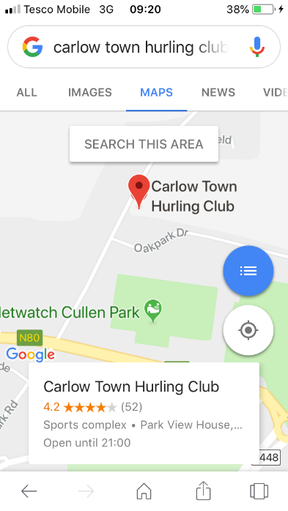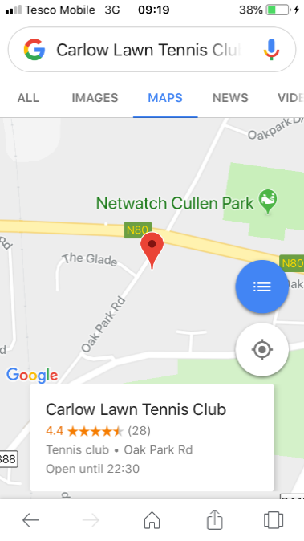

9am Number Pick Up Carlow Town Hurling Club

We will gather in the grounds of Carlow Town Hurling Club and we will all make our way to the start line Together at roughly 10.55 am sharp.

Race Start Time
11am 5 miler starts at Oak Park Arch

Finish Line
Carlow Rugby Club

Pacers for 5 Miler
32min 35min 40min 45min 50min 55 min 60min groups
(Please listen and obey the pacers guys they are there to help)

2 Water Stops Between
2 mile - 3 mile

Bottles are 200ml sports cap
( if you don’t need it don’t take it you might need it on the way back 😉)

Bins will be provided so leave bottles close when possible DONT throw them over ditches.

Order of Malta Carlow, Civil Defence & Carlow Gardai Traffic Division will be on route for the event.

Finishers Medal 🏅
Each Runner/Walker will receive our unique finishers medal.

Water will be provided after you finish so please avail of it.

Please Obey instructions from all Volunteers & Marshall’s on how to proceed after you finish.

Prizes
5 Miler

Male 1st 2nd 3rd
Female 1st 2nd 3rd

5 Miler
O/40 Male 1st
0/50 Male 1st
0/60 Male 1st

5 Miler
O/40 Female 1st
O/50 Female 1st
O/60 Female 1st

5 Miler
Junior Boy 1st
Junior Girl 1st

Presentation of Prizes

12:00 approx

Cash Only Event

Raffle 12:15 approx

A Raffle will be held on the day as always with some stunning prizes on offer
€2 a strip Or 3 strips for €5

This raffle will help raise funds for both charities.

Race Tshirts

We will have LIMITED Race Tshirts on sale for €10 each (CASH ONLY)

Display Kings

Our good friends Display Kings will once again return to our event with their Stunning Metal Medal Hangers the ideal gift or treat. Check out their stall the ideal way to display you 2023 Charlie Curran Memorial Run finishers medal.

All Designs €29 (cash or revolute accepted)

Refreshments
Please join us for post race refreshments in Carlow Town Hurling Club Race Head Quarters

Your support is very much appreciated and on behalf of Debra Ireland , Féileacáin and my family and of course my dad we thank you. Enjoy your day and I look forward to meeting you.

Thank you for your amazing support over the past 3 years in very difficult times.
Please Respect all our Volunteers as without them the event cannot take place .

Enjoy the Day and be sure to smile for the cameras.

Kind Regards
Charlie Curran

