GGR Great Gorey Run 2020/22 - Half Marathon Route
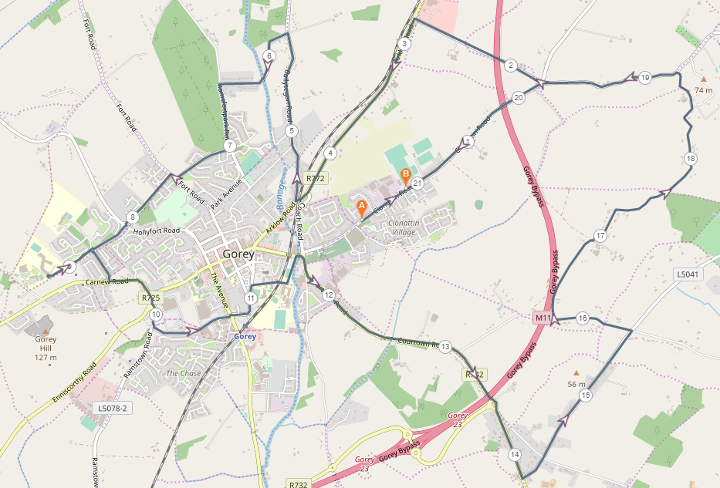
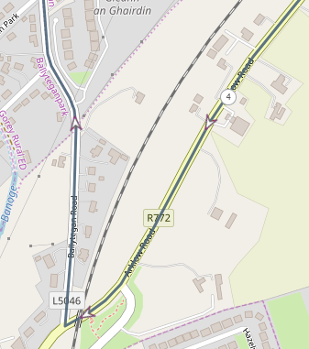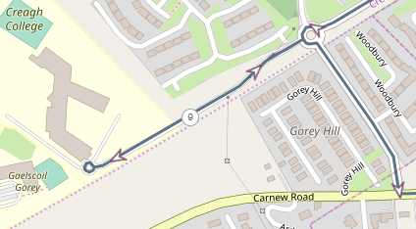
KM 4-5 (@ Arklow Road turning right unto Balltegan Road) KM 9-10 (@Creagh College)
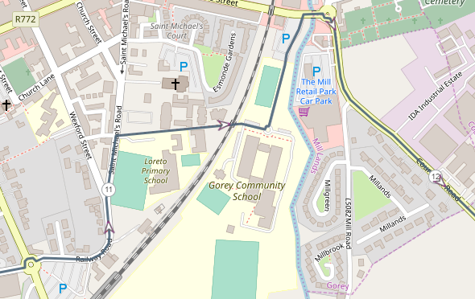
KM 11-12 (@Community School)
Route –

- Start below Naomh Eanna GAA Grounds on Clonattin Road.
- Head towards Kilmurry Cross
- Turn left at Kilmurry cross, heading towards the N11
- At the N11 (R772) turn left and continue along the hard shoulder towards Gorey Town
- Take right turn just after the railway bridge onto the Ballytegan Road
- Continue along Ballytegan Road until Ramsfort House
- Turn left heading towards Ramsfort Park
- Continue through Ramsfort Park and at the junction to Willow Park take the right turn
- Run through Willow Park and Ashwood Grove
- At the Fort Road Junction take the turn to the right onto Fort Road, followed by a quick turn to the left onto Scholars Walk
- Run straight through the first roundabout and at the second roundabout, run anticlockwise through the roundabout, taking the second exit and heading towards Creagh College
- Run around the cone at the small roundabout at the entrance to the school and back to the same roundabout taking the first exit to the right heading past Woodbury Estate
- At the next roundabout take the first exit to the left on the Carnew Road heading towards Gorey
- At the next junction run straight through past Tomkins Garage and turn right onto R725,
- At the roundabout take the first exit to the left onto Paul Funge Boulevard
- Run straight through the next roundabout past Tesco and Dunne’s Stores
- At the next roundabout take the second exit heading onto railway Road and continue to St. Michael’s Road.
- Turn right down the Mary Ward lane and enter the Community school ground.
- Turn left and head out toward Esmonde Street and turn right and head towards the roundabout.
- Turn right at the roundabout and head out the Courtown road for approx. 2km, running along the footpath towards the roundabout.
- Continue straight through the roundabout and turn left approx. 600m at Tomsilla Upper/Mountalexander (2nd exist after the roundabout)
- Continue through the crossroads along Mountalexandre road for approx. 1.4km and turn left at Ballycomclone cross and head towards the N11 by-pass bridge
- At the N11 by-pass bridge turn right heading past Molloy Salvage yard
- Continue along the road passing the entrance to Kia Ora Mini Farm
- Continue on this road up to the T Junction
- At the T junction turn left onto the Ballymoney Road heading back towards Gorey
- At the next crossroads (kilmurry cross) turn left onto the Clonattin Road
- Finish at Naomh Eanna GAA.

Zoomed Map (In Miles)
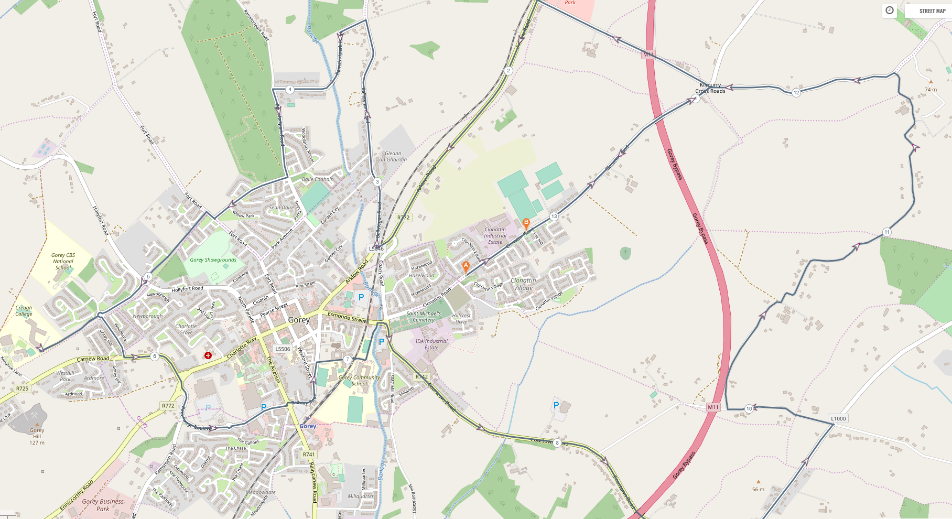
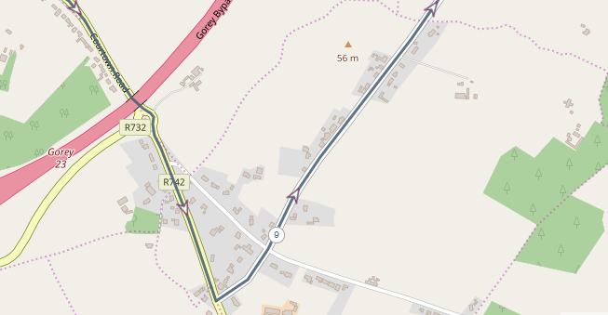

Elevations
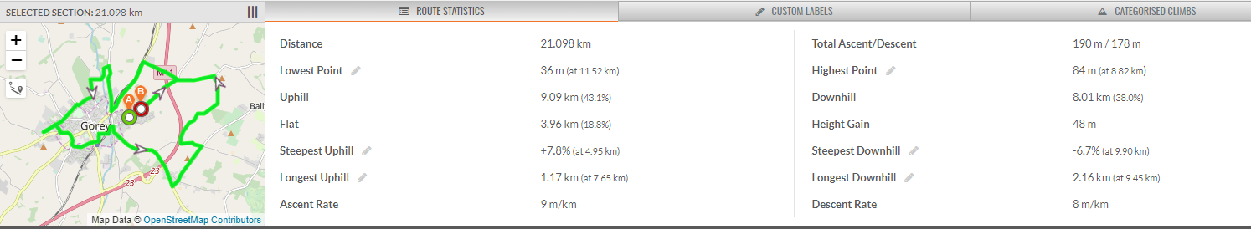

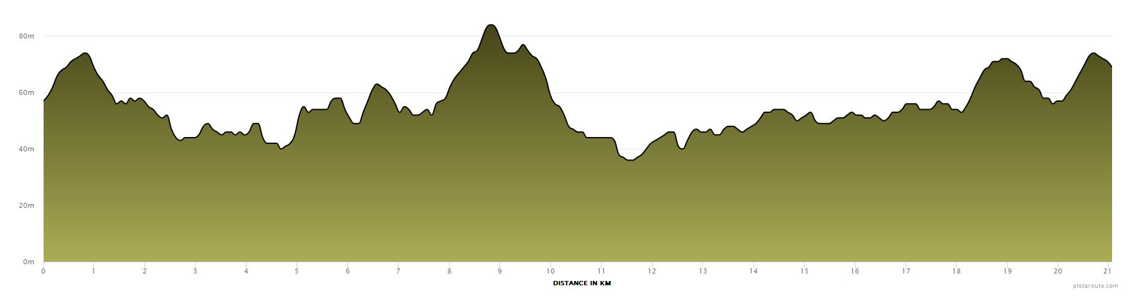

Terrain
