GGR Great Gorey Run – 5km

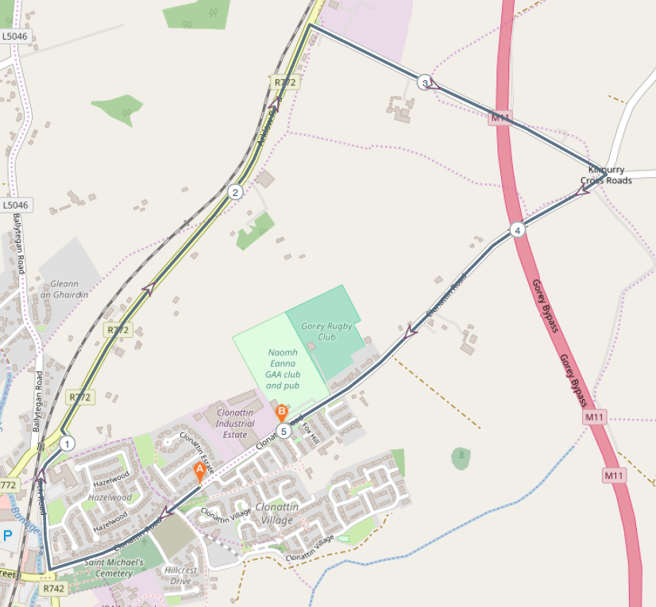

Route –
- Start just down from Naomh Eanna GAA Grounds near the entrance to Stafford’s Factory
- Run down Clonattin Hill
- take a turn to the right onto Coach Road, past The Ashdown Hotel
- Take a turn to the right onto the Arklow Road (R772) running on the hard shoulder
- At Murphy’s liquidation take a turn to the right
- At the next cross roads take a turn to the right onto the Clonattin Road
- Finish at Naomh Eanna

