GGR Great Gorey Run 2020/22 - 10Km
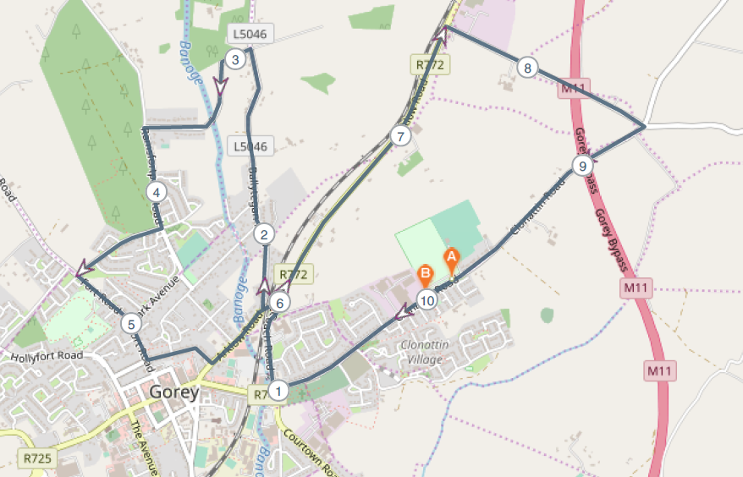

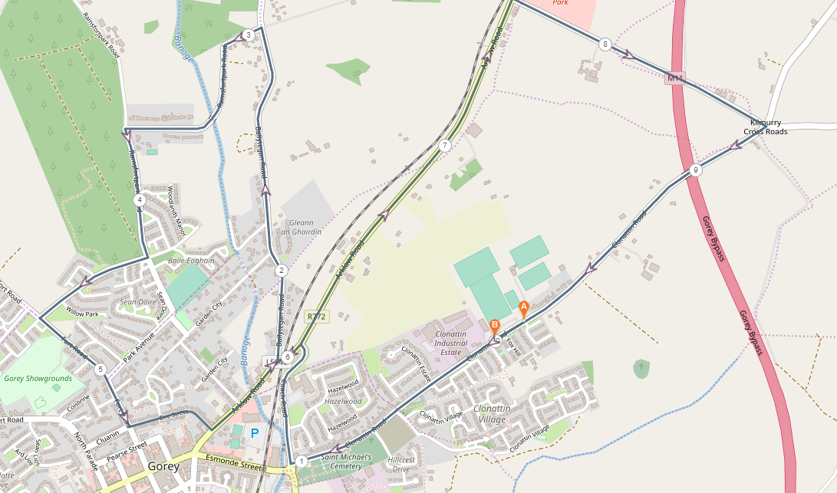

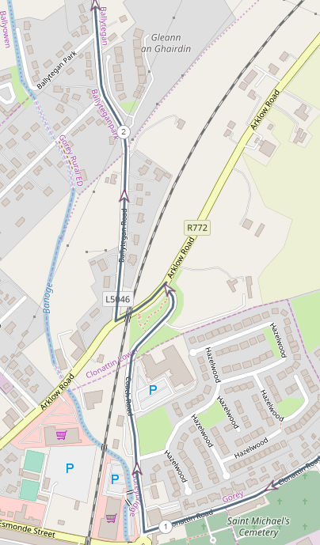
KM 1-2 (Coach Rd, turn left on Arklow Rd, turn right after bridge onto Ballytegan Road)
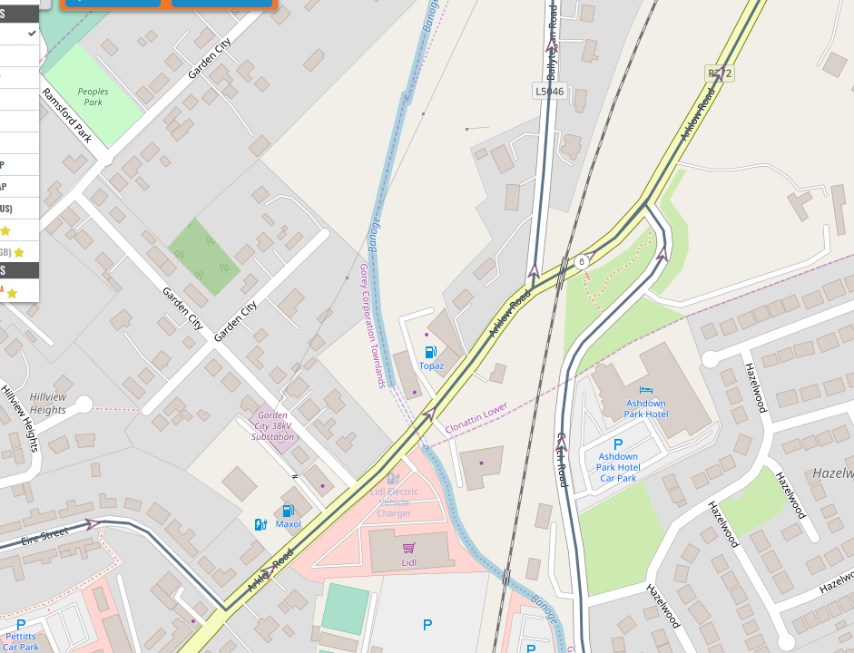
KM 5-6 @ Eire Street, turn left onto Arklow Rd and head straight out Arklow Road)
Route –

- Start at Naomh Eanna GAA Grounds
- Run down Clonattin Hill
- Take a turn to the right onto Coach Road, past The Ashdown Hotel
- At the t junction turn left heading back into Gorey town
- Just under the railway bridge take the right turn onto the Ballytegan Road
- At Ramsfort House there is a turn to the left heading towards Ramsfort Park
- The run will continue through Ramsfort Park and at the junction to Willow Park take the turn to the right
- Running through Willow Park and Ashwood Grove
- At the Fort Road Junction turn left onto Fort Road running towards Gorey Town
- At the Cluainin/Eire Street junction take the left turn onto Eire Street
- Run towards the Arklow Road
- At t junction turn left onto the Arklow Road (R772)
- Running on the hard shoulder along the Arklow Road
- At Murphy’s liquidation take a turn to the right and continue along the road
- At the next cross roads (kilmurry crossroads) take a turn to the right onto the Clonattin Road
- Finish at Naomh Eanna

Terrain
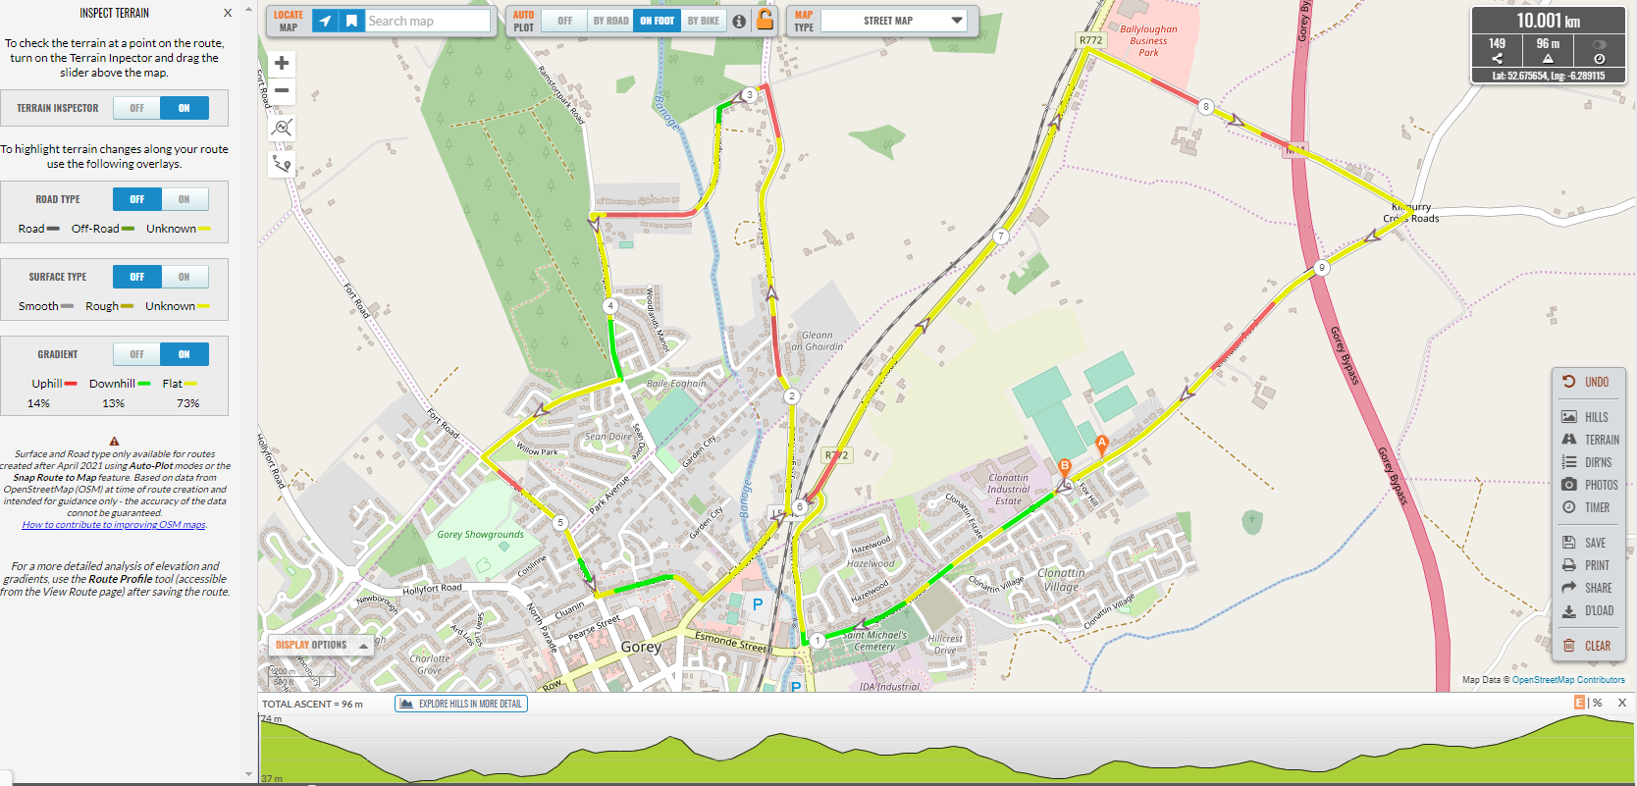

Elevation
